CHAPTER THREE
ANALYSIS AND DESIGN
3.1 Methodology
This project adopted the Waterfall Software Development Methodology. The Waterfall model is a sequential approach where development progresses through phases such as requirements gathering, system design, implementation, testing, deployment, and maintenance. Each phase must be completed before moving to the next, ensuring that the system is built systematically with well-documented processes.
The Waterfall model was chosen due to its structured approach and suitability for projects with clearly defined requirements from the beginning. It ensures that each stage of the mobile event management system is properly documented and approved before the next begins, which is essential for maintaining control and traceability throughout the project lifecycle.
The phases followed under the Waterfall model include:
- Requirement Analysis
The first stage involved collecting and analyzing user needs. Functional and non-functional requirements were gathered through informal interviews, observations, and document analysis. The goal was to define exactly what the system must do, how it should behave, and the constraints under which it must operate.
- System Design
Based on the requirements gathered, the architecture and technical specifications of the system were designed. This phase included database design, user interface mockups, module definitions, and data flow structures. The system architecture was planned to support both the frontend (React Native) and backend (FastAPI) components.
- Implementation (Coding)
After finalizing the system design, the actual development began. The frontend of the mobile application was implemented using React Native for cross-platform support. The backend APIs and database integrations were developed using FastAPI and PostgreSQL. Each module was developed according to the design specifications.
- Testing
This phase involved rigorous testing of the system components to identify and fix errors. Both unit testing (testing individual components) and system testing (testing the integrated application) were carried out. Tools such as Postman, Android Emulator, and real-device testing were used to validate both functionality and usability.
- Deployment
After successful testing, the application was deployed in a staging environment for demonstration and final evaluations. Users were given access to test features and provide feedback on functionality and design.
- Maintenance
Although not part of the current project timeline, this phase anticipates future updates, bug fixes, and performance improvements based on user feedback and evolving requirements.

3.2 Analysis of the Existing System
The existing event management process in most institutions, including the academic environment upon which this system is modeled, is predominantly manual, fragmented, and inefficient. Information regarding upcoming events is typically disseminated through multiple informal and uncoordinated channels, resulting in inconsistencies, delays, and low levels of user engagement. There is currently no centralized platform through which event organizers and participants can effectively communicate, register, or manage event-related activities.
Common methods used for event dissemination include the following:
- Physical Posters and Fliers:
These are often displayed on notice boards or distributed within the school premises. While they provide some visibility, they are time-consuming to produce, environmentally unfriendly, and limited in their ability to reach a broader audience, especially those not physically present on campus.
- Word of Mouth:
Event organizers frequently rely on personal communication networks to spread information about events. This approach often leads to incomplete or distorted information, as messages can change as they pass from one individual to another.
- WhatsApp and Other Messaging Platforms:
Group messages are commonly used to share event updates quickly. However, these messages are easily lost amid numerous unrelated conversations, making it difficult for participants to retrieve essential details when needed.
- Email Notifications:
Emails are used for formal communication, particularly for official or academic events. However, due to the high volume of daily messages, many students and staff often overlook or ignore such notifications, reducing their overall effectiveness.
Figure 3.1 illustrate event management process.
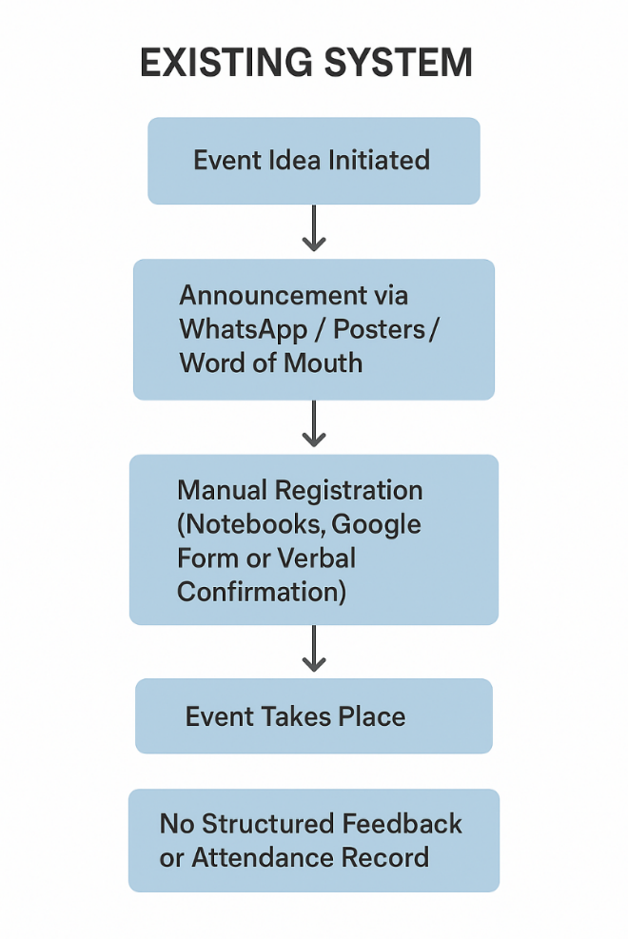
Fig 3.1 Existing Event Management Process

3.2.1 Advantages of the Existing System
The existing manual or semi-digital approach to event management, despite its limitations, offers several notable advantages that have sustained its use across many institutions:
- Low Operational Cost
The system relies on inexpensive or free communication methods such as WhatsApp groups, verbal announcements, and printed fliers. These approaches require minimal technical infrastructure, thereby reducing the financial burden on event organizers.
- Simplicity and Accessibility
Users are generally familiar with traditional communication platforms, eliminating the need for specialized training. This simplicity facilitates easy access to event information and promotes user adoption.
- Flexibility
Organizers can promptly update event details, such as time or venue, without navigating complex software platforms. This flexibility allows for rapid adjustments in response to unforeseen circumstances.

- Minimal Technical Dependence
The manual system functions effectively without heavy reliance on internet connectivity or sophisticated devices. Events can be communicated and attended even during network outages or system downtime.
- Personalized Communication
In smaller or closely-knit communities, direct word-of-mouth communication fosters stronger engagement and a sense of community between organizers and participants
3.2.2 Disadvantages of the Existing System
Despite its benefits, the existing system presents several critical shortcomings that limit efficiency, scalability, and overall effectiveness:
- Limited Flexibility
Many existing systems are not adaptable, making it challenging to accommodate last-minute changes or modifications in event requirements, schedules, or venues.
- Restricted Communication and Guest Management Features
Manual methods and basic software solutions offer limited functionality for sending notifications, managing invitations, or tracking guest responses. This restricts organizers’ ability to engage participants effectively, particularly in large-scale events.

- Weak Reporting and Analytical Capabilities
Current systems seldom provide tools for tracking attendance, monitoring event performance, or analyzing participant feedback. The absence of such insights hampers data-driven decision-making and planning improvements for future events.
- Time-Consuming and Error-Prone Processes
Manual handling of schedules, invitations, and participant information requires considerable effort and is susceptible to human error, including missed notifications, double bookings, and inaccurate records.
- Suboptimal Usability and User Experience
Some software-based solutions feature complex interfaces that hinder ease of use. Similarly, manual systems can become cumbersome and inefficient, particularly for events with a large number of participants or multiple activities.

- Inadequate Data Security
Manual record-keeping and basic digital tools often fail to ensure sufficient protection of sensitive participant information, increasing the risk of data loss, unauthorized access, or privacy breaches.
These limitations highlight the need for a modern, automated, and centralized mobile-based Event Management System, capable of enhancing flexibility, improving communication, enabling robust reporting, and providing a secure and user-friendly platform for both organizers and participants.
3.3 Proposed System Analysis

The proposed system, a Mobile-Based Event Management System (EMS), is designed to address the limitations identified in the existing event management process by providing a centralized, automated, and user-friendly platform for planning, organizing, and tracking events. The system integrates key modules that support secure user registration and authentication, event (task) management, and push notifications with reminders to ensure effective communication between organizers and attendees.
The system analysis focuses on how these modules interact to deliver a seamless event management experience.
Figure 3.2 illustrate architecture of the proposed system.

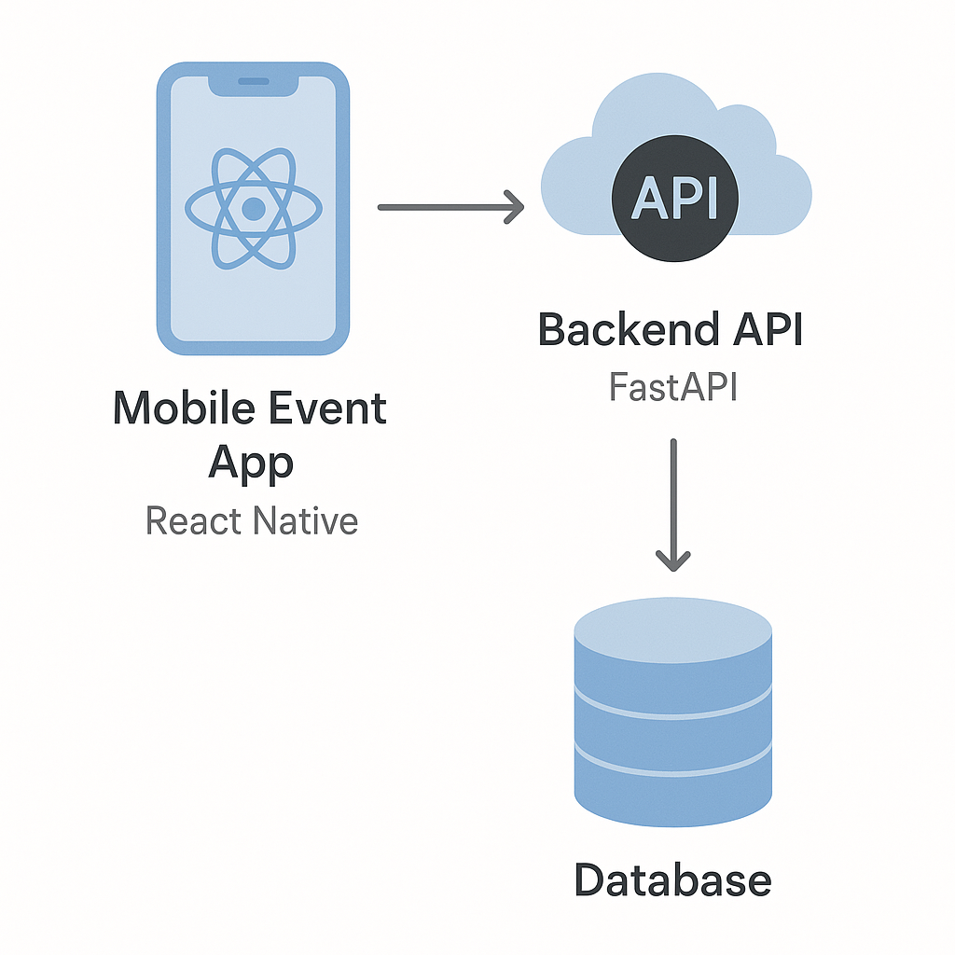
PostgreSQL
Fig 3.2 Proposed System Architecture

3.3.1 Advantages of the Proposed System
The proposed Event Management System (EMS) mobile application offers several advantages over the existing manual and fragmented processes. These advantages include:

- Enhanced Flexibility and Scalability
The system allows organizers to easily create, update, or cancel events and manage multiple events simultaneously. It can efficiently handle a growing number of users and events without compromising performance.
- Centralized Data Management
All event-related data, including user profiles, event details, and attendance records, are stored securely in a centralized database. This facilitates easy access, retrieval, and management of information.
- Improved Communication and Engagement
Features such as push notifications, reminders, and real-time updates ensure that participants receive timely information about events. This enhances engagement and reduces the likelihood of missed announcements.
- Task and Event Tracking
The system allows organizers and participants to track tasks, deadlines, and progress across various stages of an event. This ensures better organization and accountability.
- Secure User Authentication
The inclusion of secure registration and authentication mechanisms ensures that user data and event access are protected from unauthorized use.
3.3.2 Disadvantages of the Proposed System
While the proposed Event Management System (EMS) mobile application provides several benefits, it also presents certain disadvantages and limitations that must be acknowledged:
- Initial Development and Maintenance Cost
Developing and maintaining the mobile application requires financial resources for software tools, hosting services, and periodic updates. This may pose challenges for institutions with limited budgets.
- Dependence on Internet Connectivity
Since the system is mobile-based, stable internet access is required for real-time communication and updates. Users in areas with poor connectivity may experience limited functionality.
- Technical Skills Requirement
Administrators and some users may require basic training to effectively use the application. Lack of technical literacy could reduce adoption rates among certain groups.
- Device Compatibility Issues
The system may not function optimally on all devices, especially older smartphones with outdated operating systems. Ensuring compatibility across platforms may require additional development effort.
- Data Privacy and Security Risks
Storing event and user data in digital form increases the risk of unauthorized access or cyberattacks if proper security measures are not implemented.
- System Downtime
Technical failures, server downtime, or software bugs could temporarily disrupt access to the system, affecting the reliability of event coordination
3.4 System Design
The system design defines the structure and operation of the Event Management System. It transforms requirements into technical models that guide development. Key design components include:
- Use Case Diagram – illustrates interactions between users (students, organizers, admin) and the system.
- Entity–Relationship Diagram (ERD) – represents database entities such as users, events, and their relationships.
- Data Flow Diagram (DFD) – shows how data moves between processes like login, event creation, and notifications.
- System Architecture Diagram – depicts the three-tier design: mobile app (frontend), backend server (API), and database.

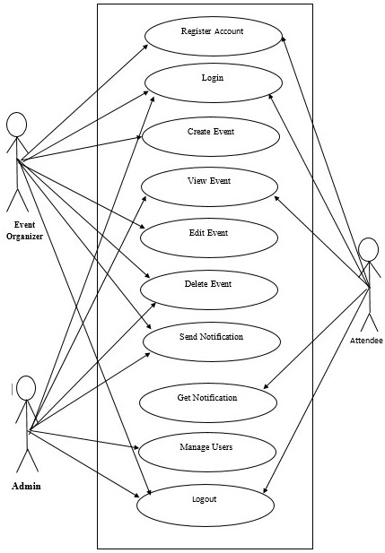
Fig 3.4.1 Use case Diagram
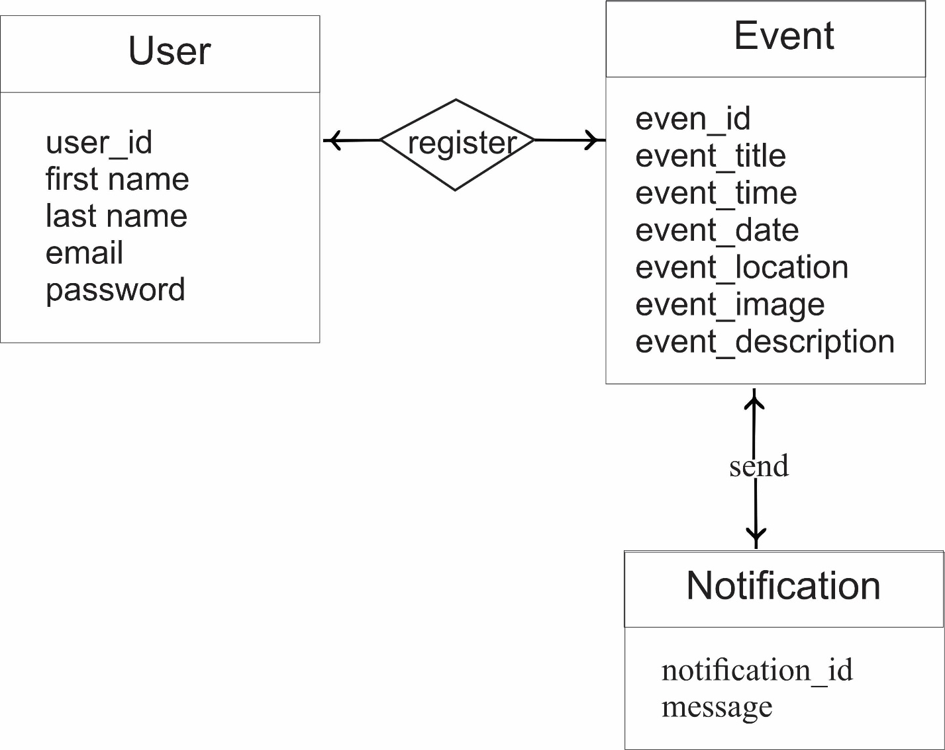

Fig 3.4.2 Entity Relationship Diagram

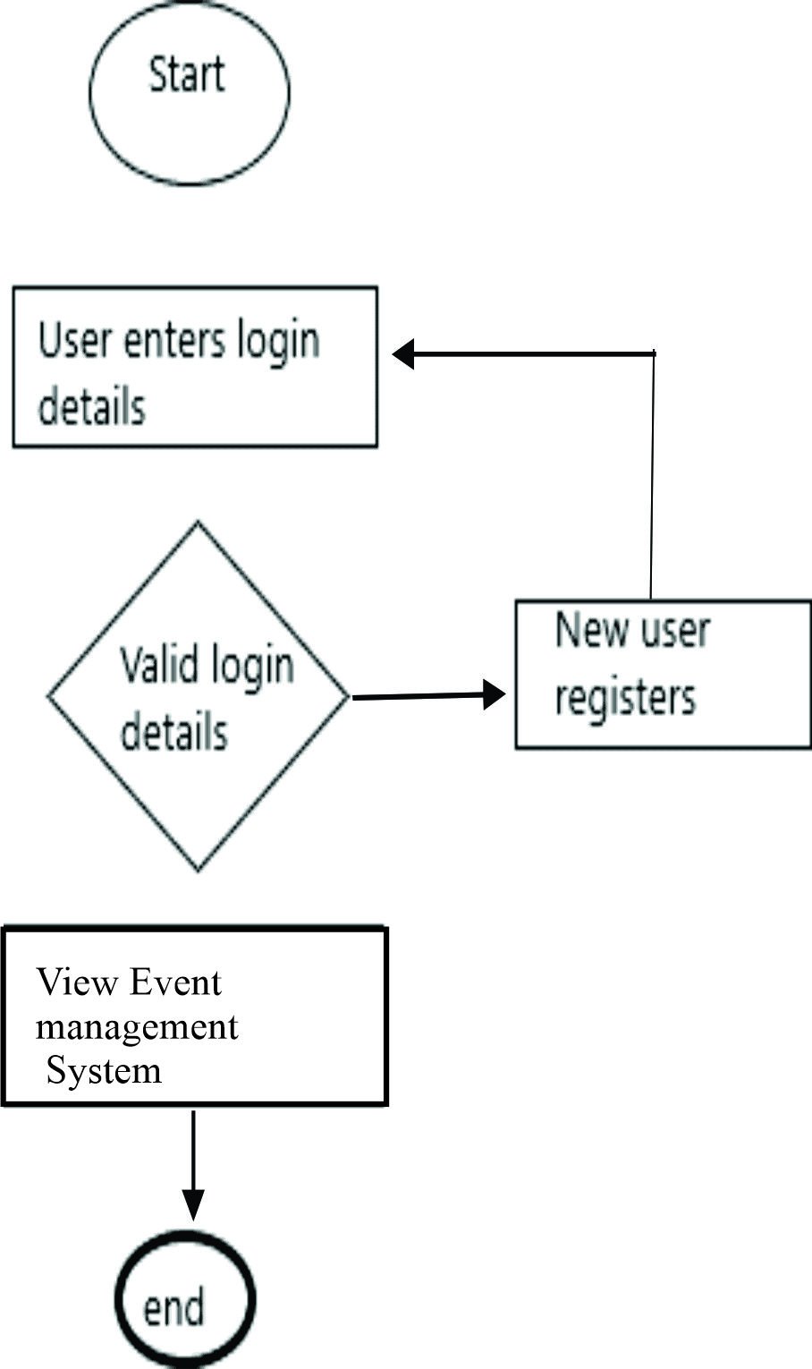

Fig 3.4.3 System Flow Chart Diagram

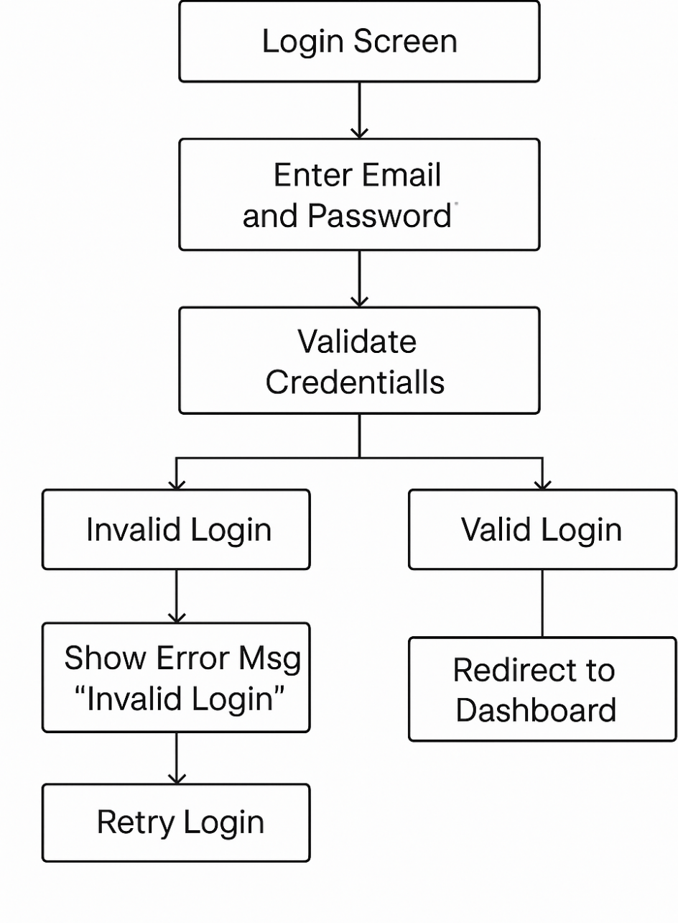

Fig 3.4.4 Login Flowchart

